**Course Specialist Test 2 Year 12**

Student name: ________________ Teacher name: ________________

**Task type: Response/Investigation**

**Reading time for this test : 5 mins**

**Working time allowed for this task: 40 mins**

**Number of questions: 7**

**Materials required:** Upto 3 classpads/calculators

Standard items: Pens (blue/black preferred), pencils (including coloured), sharpener, correction fluid/tape, eraser, ruler, highlighters

Special items: Drawing instruments, templates, notes on one unfolded sheet of   
A4 paper, and up to three calculators approved for use in the WACE examinations

**Marks available: 42 marks**

**Task weighting: 13%**

**Formula sheet provided: no but formulae stated on page 2**

**Note: All part questions worth more than 2 marks require working to obtain full marks.**

**Useful formulae**

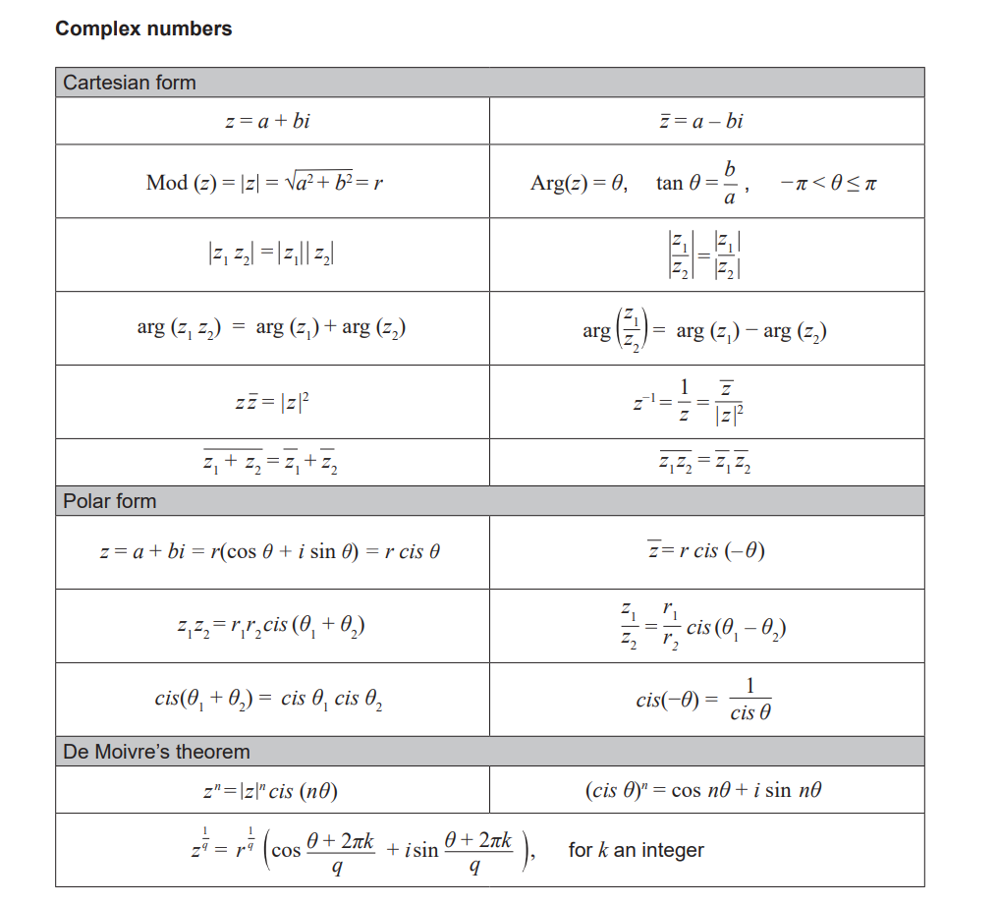



Q1 (2 & 3 = 5 marks)

Consider the function plotted below.

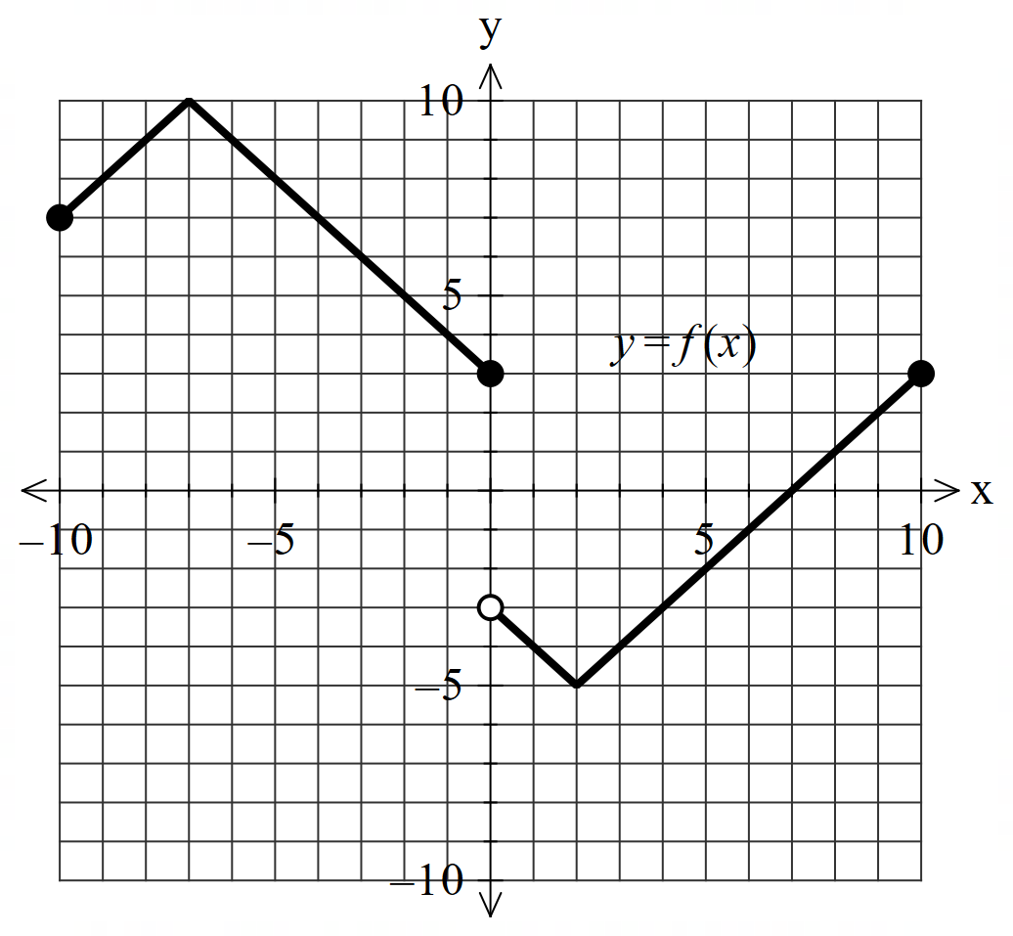

1. Solve for .
2. Sketch  on the axes below.

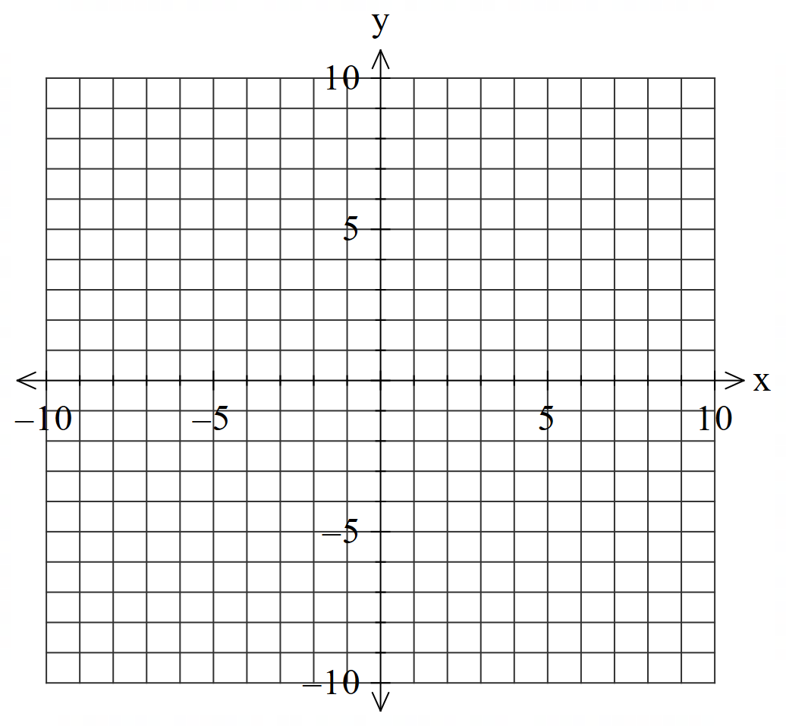

Q2 (2, 3 & 3 = 8 marks)

Consider the functions  and .

1. Determine the natural domain and range of .
2. Does  exist over the natural domain of ? Explain.
3. Determine the largest possible domain for .

Q3 (3, 3, 1 & 2 = 9 marks)

Consider the function .

1. Determine  and state its domain.

Q3 continued

1. Sketch  on the same set of axes below.

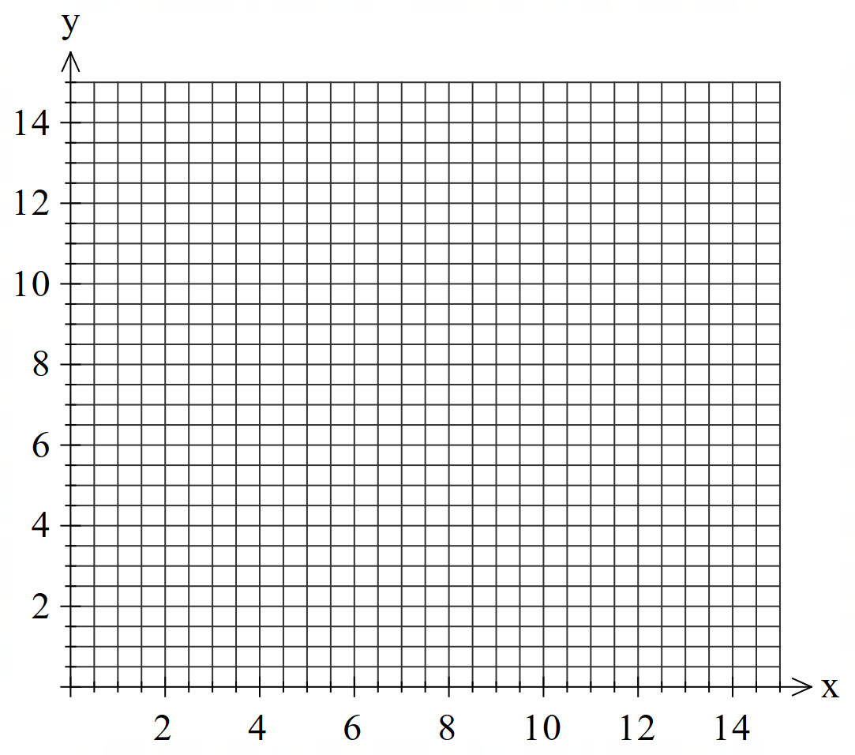

1. Determine 
2. Determine value(s) of , if any, such that . Explain.

Q4 (3 marks)

If  is a solution to the equation  where  is a positive real number and  is a positive integer, determine the smallest possible value for in the form . **Justify** your answer.

Q5 (3 & 3 = 6 marks)

Consider a triangular plane with vertices shaded as shown below. There is a light globe situated at point .



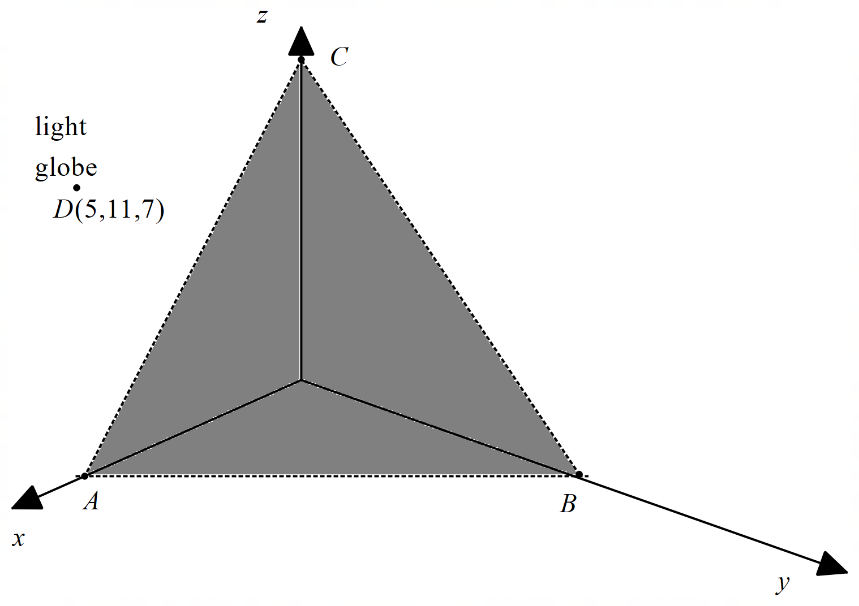

1. Determine the cartesian equation of the shaded plane  above.

Q5 continued

1. Determine the distance of the globe to the shaded plane .

Q6 (5 marks)

Consider the line A  and the sphere B  where  is a real constant.

Determine all possible values of ,to one decimal place such that:

1. the line misses the sphere.
2. the line just touches the sphere.
3. the line pierces the sphere at two points.

Q7 (3 & 3 = 6 marks)

Consider two rockets  that are ignited at the same time from different positions and move with constant velocities as shown below.



Both rockets leave a smoke trail that stays in the air for at least 6 hours.

1. Determine the distance of the closest approach between the rockets using **scalar dot** product (3 marks)

Q7 continued on next page

1. Determine the exact point in space, if any, where the smoke trails overlap at some time in the first 6 hours. (3 marks)

Working out space

Working out space

Working out space

End of test